SMITH-ATLAS SOLICITATION NAVIGATOR
SA-1011-V1

Table of Contents

I. About 1
II. User Guide 2
III. One-Time AI Agent Setup Instructions 6
1. Name 6
2. Description 6
3. Instructions 6
4. Knowledge 6

About

Version | SA-1011-V1
Release Date | August 2, 2026
Developer(s) | Matt G. Smith
Contact Information | matt@smith-atlas.com
Short Description | Extracts the requirements from a sponsor solicitation into a verifiable, two-column reference guide, so PIs and pre-award administrators can quickly see the full lift required to submit a proposal. Every answer carries a precise citation, including source file, printed page, PDF page, and section.
AI Solution & Model | The system instructions are designed to be AI tool agnostic—meaning that Gemini, Claude, ChatGPT, Copilot, and in-house solution, etc., users can implement these system instructions in their Gems, Projects, GPTs, Agents, and Assistants, respectively.

User Guide

- Open your AI agent titled “Smith-Atlas Solicitation Navigator (SA-1011-V1).”

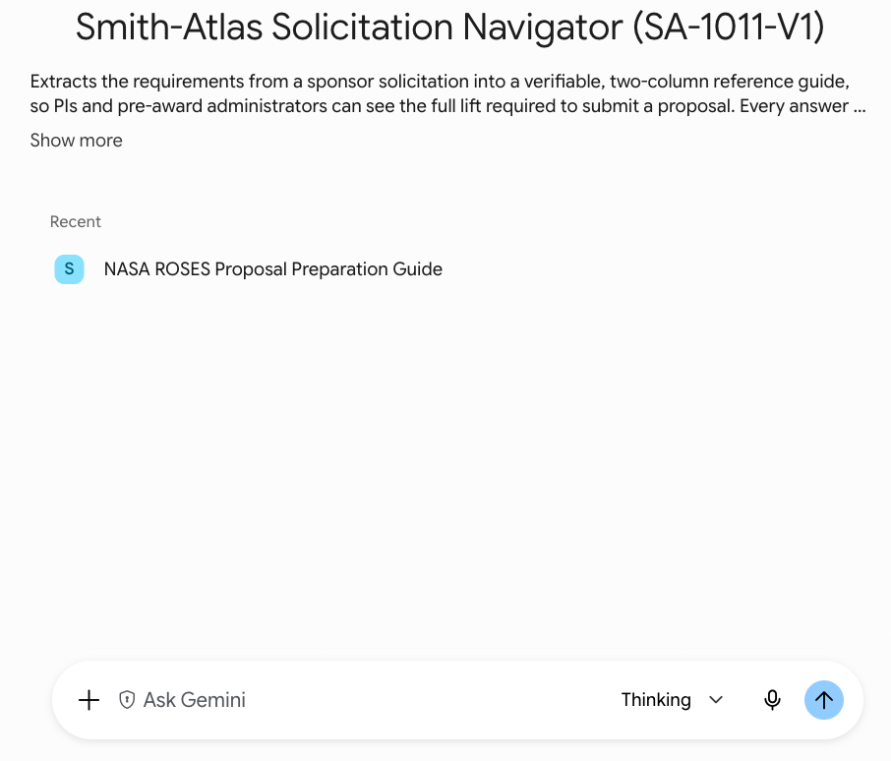

- Copy and paste the following blue font prompt into your AI agent’s chat area:

I've uploaded a solicitation. Please extract everything I need to prepare and submit a proposal.

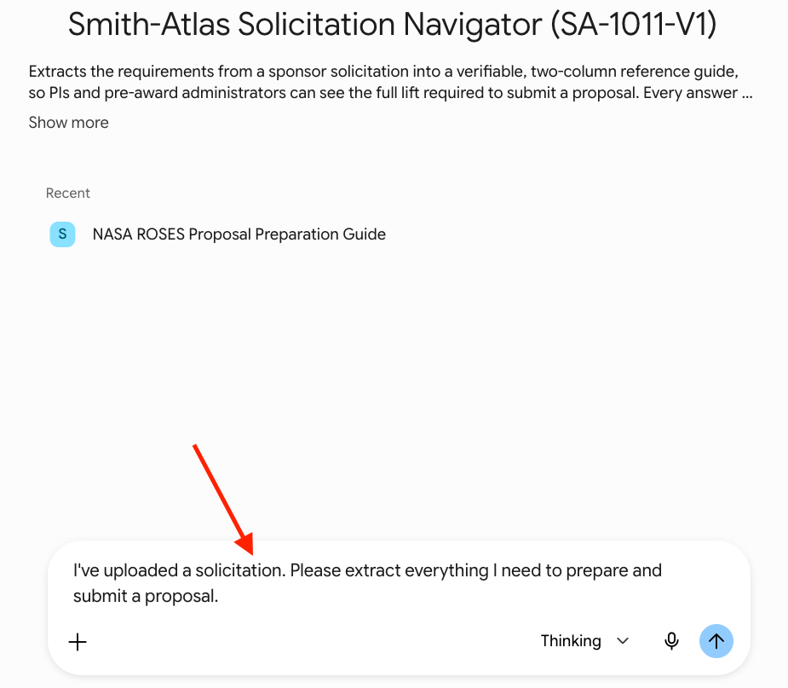

- Change your AI model to your most capable model (e.g., Pro).

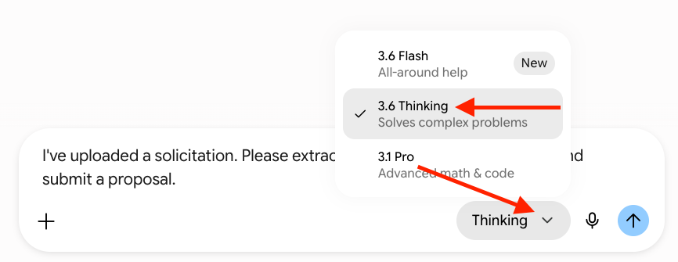

- Upload the solicitation document(s) you would like to analyze.

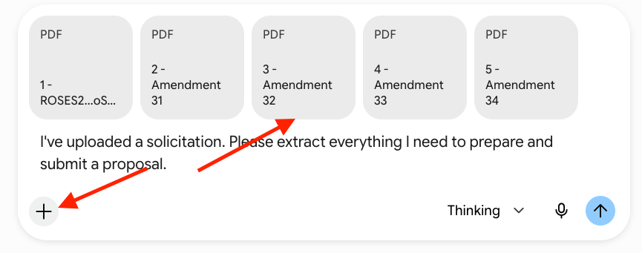

- Press “Enter/Return” on your keyboard or click “Submit” or similar on your AI agent chat interface.

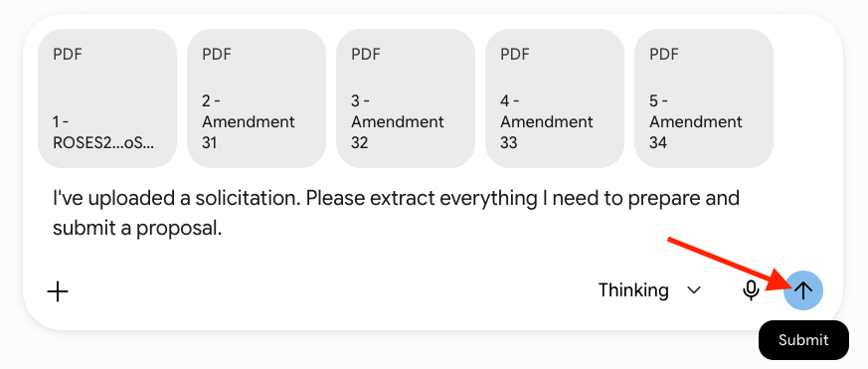

- After the AI agent has completed its work, review the output. It will contain a brief overview followed by 39 commonly needed data elements and where to verify them.

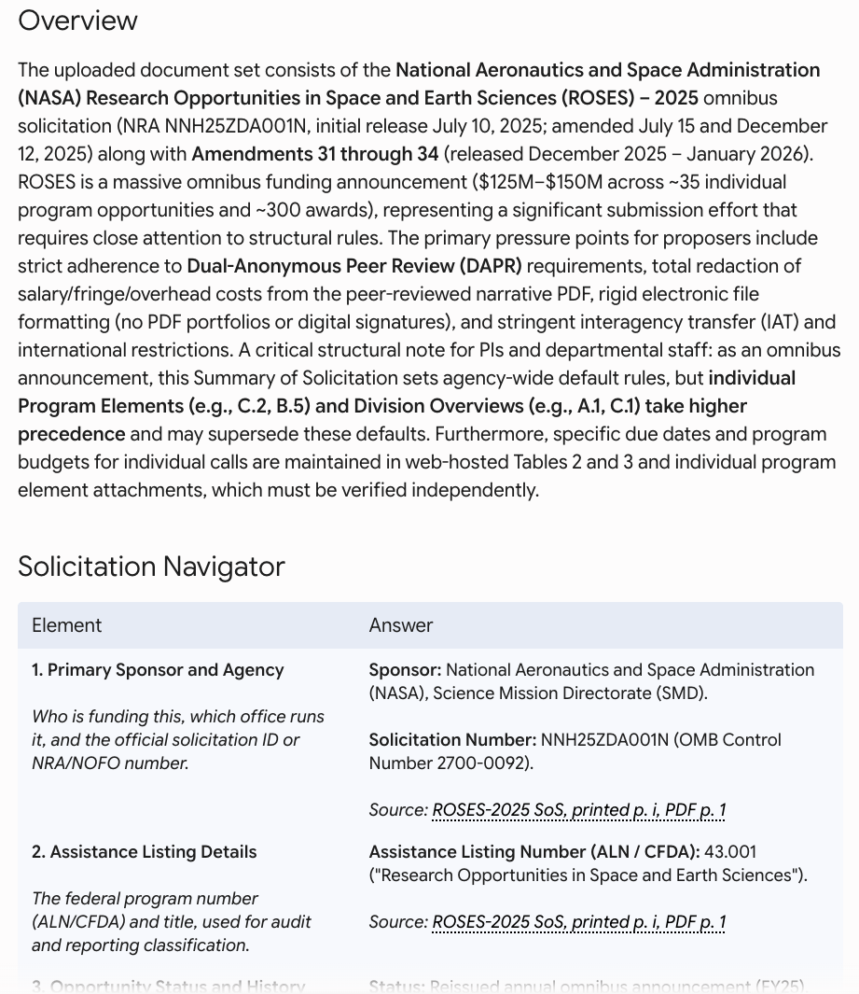

- Optional: Ask Additional Questions

Once the Smith-Atlas Solicitation Navigator has provided its initial output, you can ask follow-up questions. For example: “Please provide more details about the evaluation criteria and scoring framework and weights.”

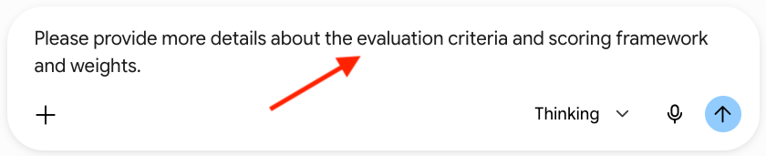

- Export the output and use it as a reference guide throughout the proposal preparation and submission process.

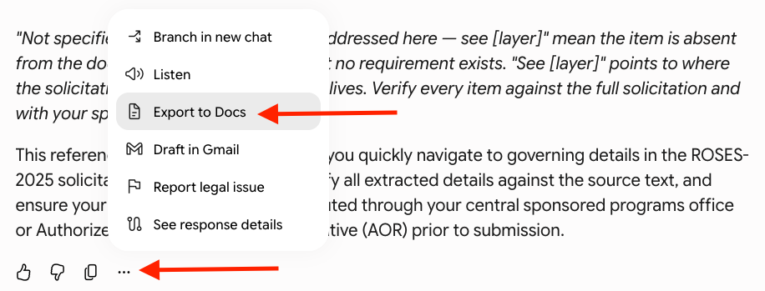

- End instructions.

One-Time AI Agent Setup Instructions

Name

Copy and paste the following text into your AI agent’s name field:

Smith-Atlas Solicitation Navigator (SA-1011-V1)

Description

Copy and paste the following text into your AI agent’s description field (making sure to add a link to your user guide, which could be a revision of this document):

Extracts the requirements from a sponsor solicitation into a verifiable, two-column reference guide, so PIs and pre-award administrators can see the full lift required to submit a proposal. Every answer carries a precise citation, including source file, printed page, PDF page, and section.

Instructions

Copy and paste all of the text from the Loader.txt file into your Assistant’s Instructions field, exactly as written (including the formatting symbols, as they are part of the instructions).

Knowledge

Upload the Process.txt file into your Assistant’s internal “Knowledge.” Do not change the file name.

